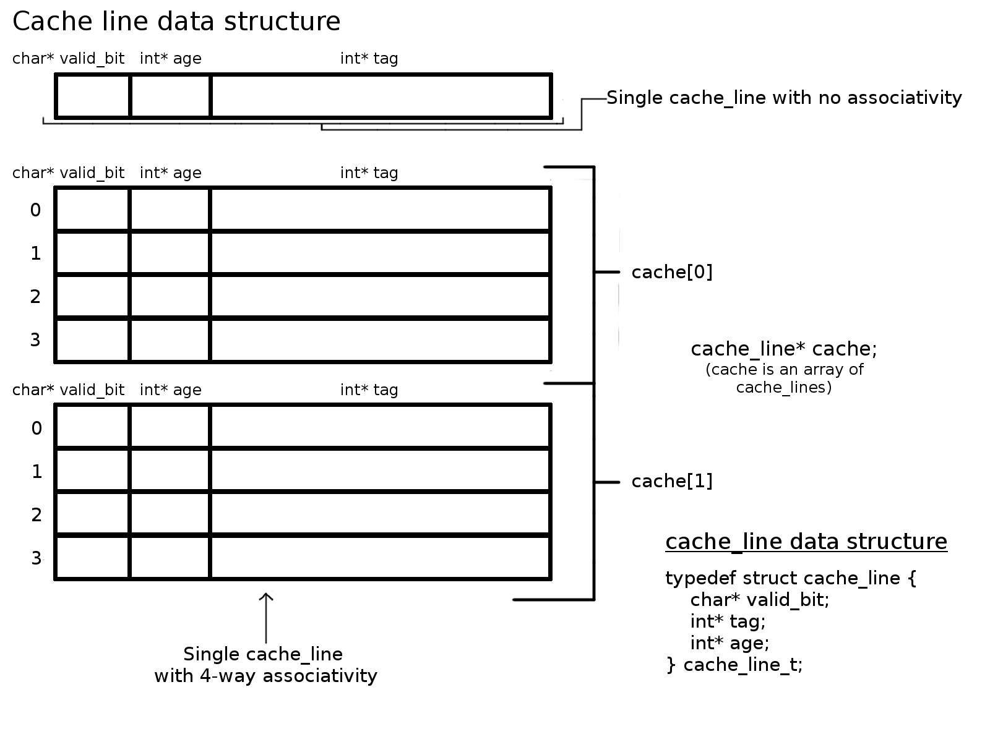The cache simulator consists of three functions with an additional to initialize it (iplc_sim_init). The cache itself as a data structure is an array of cache indexes or "cache_lines" which are consisted of a char array (valid bit) and 2 int arrays(one for age, one for tag). The size of these arrays will be the level of associativity i.e. for a 4-way associativity, each array would be of size 4.

iplc_sim_init:

The cache data structure is initialized in the iplc_sim_init function. Calloc is used for int* age and char* valid_bit because we want those values as 0 by default. Malloc is used to allocate memory for the int* tag because we will manually initialize the values during a miss.

iplc_sim_trap_address:

The "driver" function of the cache simulator is the iplc_sim_trap_address which is called during the parse_instruction function. The trap_adress function takes in a given address, strips it down into its components of index and tag (the BOB was calculated during initialization with a given formula). Once the cache index is calculated (cache[index]), we only need to look within that index for the block with the calculated tag. We then iterate through that index which is the size of the associativity number. At each line in the known index, we must check if the valid bit is 1 and if tag in the line matches the one we are trying to store. If both of those are true, we have a HIT. We increment the hit counter (cache_hit) and call our function to update on HIT. If we never find a match, we increment the MISS counter (cache_miss) and call our function to replace on MISS. After either a hit or miss, we increment the cache access counter and return a 1 for a hit and a 0 for a miss.

iplc_sim_LRU_replace_on_miss:

Given the index and tag from trap_address(), we look in the target index (cache[index]) for a valid_bit of 0. This signifies an unused line and will be our target line if found. If there is no valid_bit equal to 0 then this index in the cache_line is full. We must then find and replace the oldest block. This is because older pieces of data are less likely to be accessed than newer ones. While we are looping through the index looking for a valid bit of 0, we are also keeping track of the oldest bit we find. If there is no valid bit found, we will use the line with the

oldest age as our target line. We then, in the target line,set the values of the tag in the corresponding line to the tag we are looking to store and change the valid bit to a 1. We now need to update the

age of each line that has data, i.e. valid bit of 1. Thus, we call update_on_hit.

iplc_sim_LRU_update_on_hit:

Given the cache_index and the line number in the index of the line that was just accessed, we must update the age of each line that has data. We first set the age of the line which we just accessed to 0. We then loop over the entire index and increment each lines age by 1 given they have a valid bit of 1. Thus, the line we just accessed is now of age 1.

Pipeline Write-Up

Whenever an instruction is called the corresponding function calls the main driver function to execute the remainder of the current instruction and then adds the relevant data into the pipeline’s instruction fetch.

As the instruction are run the data moves along in the pipeline.

The following describes the flow of the main pipeline function.

Write Back:

We must always check to be sure that write back has finished so that we can count the number of instructions. Otherwise we don’t do anything that is we insert nops and increment the stall counter.

Branch:

We then do branch predictions. We check at the decode stage if our current instruction is a branch instruction. Then we compare the instruction in decode with the instruction in fetch. If the instruction in fetch is greater than 4 after our current instruction, then we didn’t take it, otherwise we decide to take the branch.

If we predict correctly we increment the prediction counter, and we stall if our prediction was wrong.

Load Word:

We check for delays due to use in ALU stage, it there is a data hit/miss we add to our stall if needed.

Store Word:

We check for memory access and data misses, we stall if there is a miss/hit.

We then increment the number of cycles.

We copy data from memory to write back, from ALU to memory, from decode to ALU, and from fetch to decode.

We finally zero the bits so that we can put in the correct instruction or leave it as NOPs, so that we know to stall.

In actuality, the pipeline is not really so complicated. All of the instruction functions do just about the same thing and the main driver function simply works through one pipeline cycle.

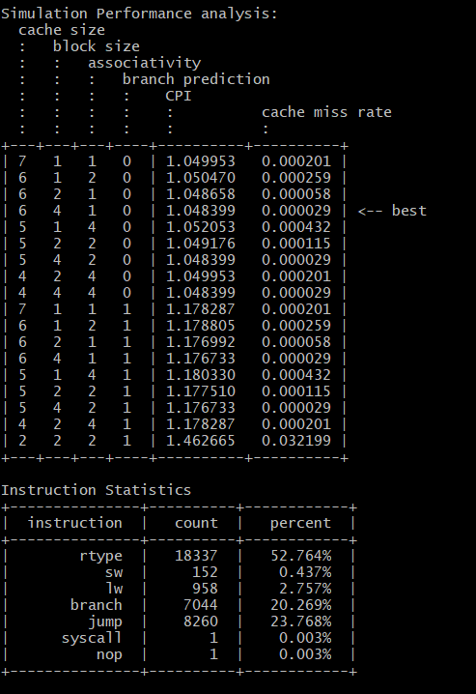The Performance Analysis tests the Instruction pipeline and cache (IPLC) simulator by running the simulator eighteen times. There are nine different cache configurations that are each tested with branch predictor configured TAKEN and branch predictor configured NOT-TAKEN. To accomplish this, first an array pa_sims is created where pa_sims is a struct that holds each simulations configuration and the resulting CPI and cache miss rate. This array of pa_sims is passed into the run_pa function, which does the rest of the work. In run_pa, the configurations are created as an array of length eighteen for each configuration option (index, blocksize, association level, branched). These configuration are looped over and the simulations are run. The instructions file is read, iplc_sim_finalize() and the array of pa_sims is filled out. The output is then printed through the pretty_print_table function.